**LAB 4**

**AIM: Implement following Image Enhancement Techniques –**

* **Intensity Level Slicing**
* **Bit Plane Slicing & Reconstruction**
* **Histogram Equalization**

**1. Take your own photo and separate out its bit planes.**

**a. Reconstruct your image using higher order 2 bit planes.**

**b. Reconstruct your image using higher order 4 bit planes.**

**c. Experiment with the bit planes and derive your conclusions.**

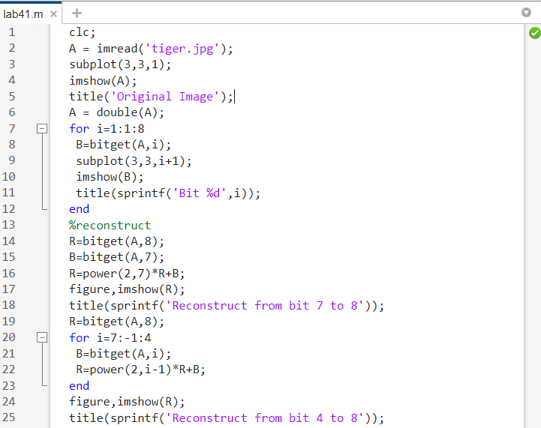

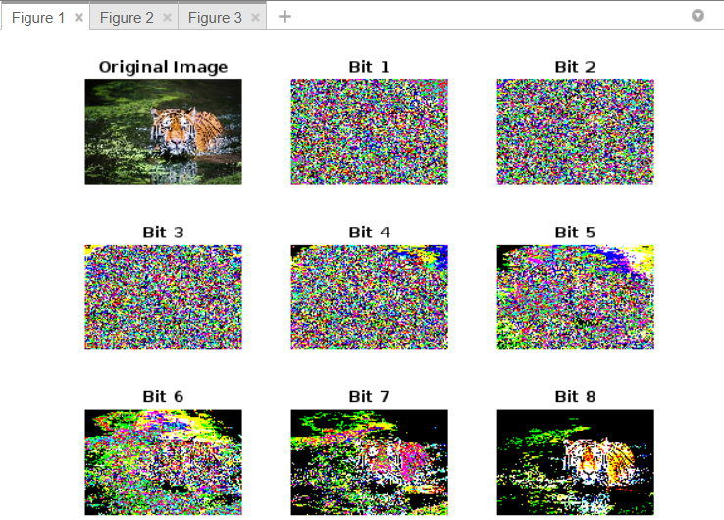

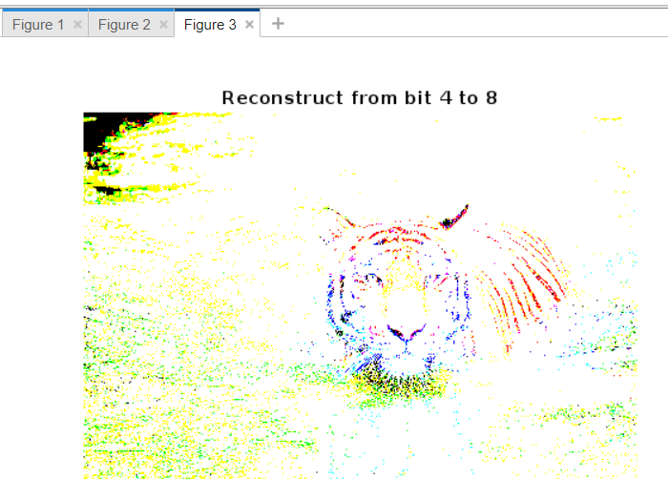

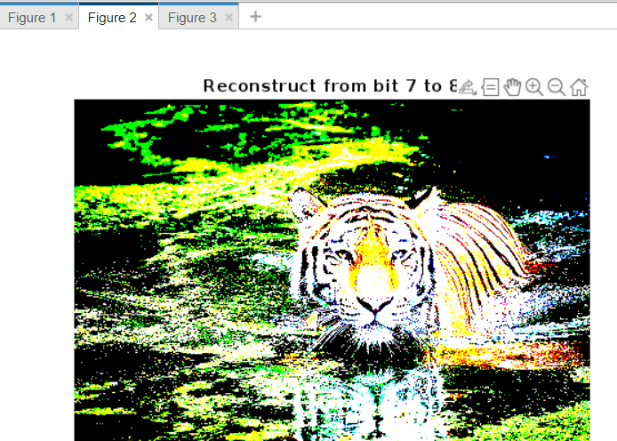

**2. Consider the image kidney.tif and perform intensity level slicing transformation**

**within the range (150 – 230)**

**a. Highlight the given intensity range and keep all other intensities to a lower**

**level.**

**b. Highlight the given intensity range and keep all other intensities as it is.**

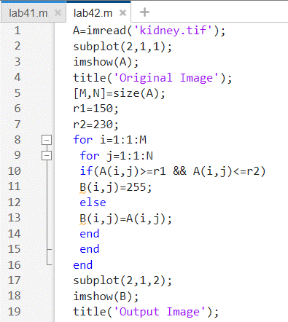

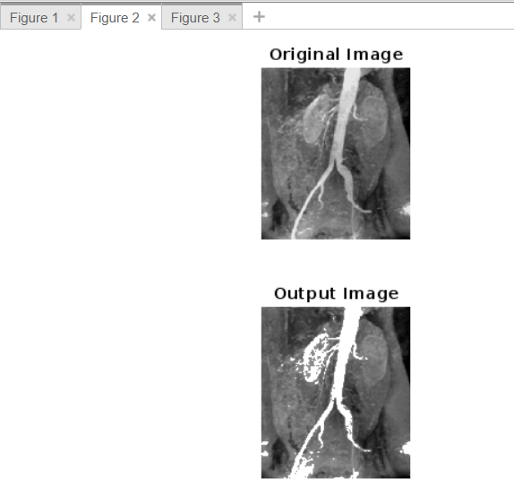

**4. Histogram Equalization:**

**a. Create a function that would be able to perform histogram equalization on**

**a grayscale image.**

**b. Use this function to equalize a low contrast image ex_contrast.tif (from**

**Lab 2)**

**c. Use the function histeq(image) on the same image ex_contrat.tif.**

**d. Compare the results of b) and c)**

